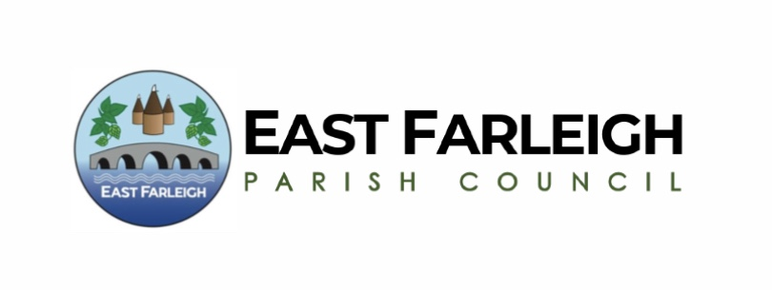

ANNUAL PARISH MEETING FOR EAST FARLEIGH
Tuesday 26th March 2024 at 6.30pm.
East Farleigh Primary School, East Farleigh

AGENDA

1. Opening Address by Cllr Alex Fullwood, Chair, East Farleigh Parish Council.

2. Apologies for absence.

3. To ask for notification of whether anyone intends to film, photograph or record any items.

4. Kent Police representative’s Report.

5. Minutes of the Annual Parish Meeting held on Tuesday 28 March 2023.

6. County Councillor’s Report.

7. Borough Councillors’ Reports.

8. Report from the Chairman of East Farleigh Parish Council.

9. Reports from Village Organisations and Representatives.

10. Public Forum.

11. Date of next Annual Parish Meeting – To be advised.

Alexandra Fullwood

Cllr Alex Fullwood
Chair East Farleigh Parish Council

